**SYSTEM ANALYSIS**

**INTRODUCTION**

After analyzing the requirements of the task to be performed, the next step is to analyze the problem and understand its context. The first activity in the phase is studying the existing system and other is to understand the requirements and domain of the new system. Both the activities are equally important, but the first activity serves as a basis of giving the functional specifications and then successful design of the proposed system. Understanding the properties and requirements of a new system is more difficult and requires creative thinking and understanding of existing running system is also difficult, improper understanding of present system can lead diversion from solution.

**ANALYSIS MODEL**

The model that is basically being followed is the SPIRAL MODEL, which states that the phases are organized in a linear order. First of all the feasibility study is done. Once that part is over the requirement analysis and project planning begins. If system exists one and modification and addition of new module is needed, analysis of present system can be used as basic model.

The design starts after the requirement analysis is complete and the coding begins after the design is complete. Once the programming is completed, the testing is done. In this model the sequence of activities performed in a software development project are: -

* Requirement Analysis
* Project Planning
* System design
* Detail design
* Coding
* Unit testing
* System integration & testing

Here the linear ordering of these activities is critical. End of the phase and the output of one phase is the input of other phase. The output of each phase is to be consistent with the overall requirement of the system.

SPIRAL MODEL was defined by Barry Boehm in his 1988 article, “A spiral Model of Software Development and Enhancement. This model was not the first model to discuss iterative development, but it was the first model to explain why the iteration models.

As originally envisioned, the iterations were typically 6 months to 2 years long. Each phase starts with a design goal and ends with a client reviewing the progress thus far. Analysis and engineering efforts are applied at each phase of the project, with an eye toward the end goal of the project.

**The following diagram shows how a spiral model acts like:**

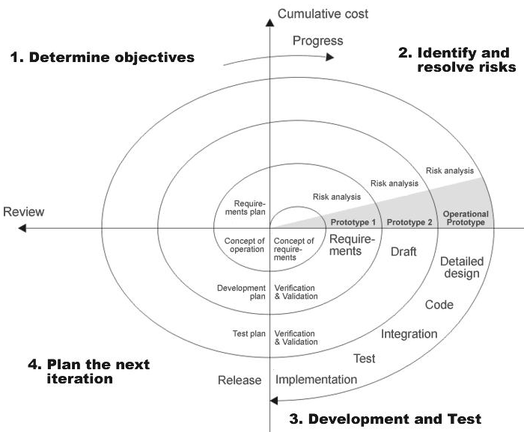

**STUDY OF THE SYSTEM**

To provide flexibility to the users, the interfaces have been developed that are accessible through a browser. The GUI’S at the top level have been categorized as

**Modules:**

After looking at the functional requirements it is identified that we can divide the system into mainly following modules:

* Admin Module
* Student Module
* Lecturer Module

**Administrators:**

In this modulehelps administrators get the most accurate information to make more effective decisions. Employees and administrators gain time saving administrative tools. Itequipped features makes it possible to create faculty, students, view the students and view the faculties.

**Add department**: admin can add department details.

**Add Faculty:** admin can add a faculty

**Add Student:** admin can add a student

**Feedback:** admin can view the feedback of all faculty members

**logout**

**Student Module:-**

This module maintains the information related to the Feedbacks and Self details.

**View profile:** student can login and view his profile

**Feedback:** student can send feed back

**Faculty Module:**

This module maintains the information related to the search feedbacks by year-wise, branch-wise, and semester-wise.

**View profile:** faculty can login and view his profile

**Feedback:** faculty feed back

**HARDWARE & SOFTWARE SPECIFICATIONS**

**Hardware Requirements:**

|  |  |  |  |
| --- | --- | --- | --- |
| **Client Side** | | | |
|  | **Processor** | **RAM** | **Disk Space** |
| **Internet Explorer 6.0**  **Or Higher** | Computer with a 2.6GHz processor or higher (Pentium processor recommended) | 512MB Minimum | Minimum 20 GB |
| **Server Side** | | | |
| **Apache Tomcat** | Intel Pentium processor at 2.6GHz or faster | Minimum 512 MB Physical Memory; 1 GB Recommended | Minimum 20 GB |
| **Net Beans 6.8**  **Oracle10g** | Intel Pentium Processor at  2.6GHz or faster | Minimum 512 MB Physical Memory; (1 GB Recommended) | Minimum 20 GB |

**Software Interface:**

* **Client on Internet/Intranet:** Any web browser.
* **Web Server:** Apache Tomcat.
* **Database Server:** Oracle10g.
* **Development End:** NetBeans 6.8.

**EXISTING SYSTEM**

In the existing system the faculties have to take care of the students and collect all the feedback details and verification has to be taken manually.The existing system is manual and the manual system works in the following way:

**Limitations of the Existing system:**

* The faculty of particular department can assign because of that its take more time consuming to the faculty as well as student.
* If any personal details related to the student/staff have been tainted then the details has to be submitted to the college.
* If any personal details related to the student have been changed then the details has to be submitted to the College. This process is to be taken manually.
* Within a College the interactions between Principal (Admin), Faculties and the Students have been done manually.

Till now most of the schools has adopted the above manual system that produces lot of problems and at the same time the following disadvantages are there with the above system.

* The increasing complexity,
* producing the reports as desired is not possible,
* it is Manual system so it is time consuming

**PROPOSED SYSTEM**

To overcome all the difficulties of the existing system the management has proposed automated the whole system and the development of the new automated system contains the following activities, which try to automate the entire process keeping in view of the database integration approach.

**Advantages of Proposed System:**

* By developing this system we can provide better security to our data And reports will be gained accurately.
* Administrator is able to view create the faculty, students and he is also able to view the students and the faculty members also.
* It provides complete activity as automated system.
* It is not limited to a single system because it is aimed to develop for web based environment.
* The student information is available to the administrator and also to the faculty.